Experiment no. 10

Name:- Nehal D. Ughade PRN no :- 21520009

Course name:- ADS Lab Date- 27/04/2023

**Title** : Cassandra Clustering

**1. Setup a multi-node Cassandra Cluster on single windows machine.**

**2. Install the DataStax OpsCenter community edition and configure it for above cluster formed.**

**3. Use Case - Weather Station IoT Temperature Sensor Data: There are set of weather stations at different remote location with “weatherStationID”. Each station records the temperature after every 5 minutes and push the data to nearest node in above cluster. Design the cluster database to hold these weather data. User should be able to retrieve the data in any dimensions.**

**4. Demonstrate the cluster operations of above use case using OpsCenter.**

**Installation Of DataStax OpsCenter:**

Download the DataStax OpsCenter Community Edition zip file from its website and run the installer.

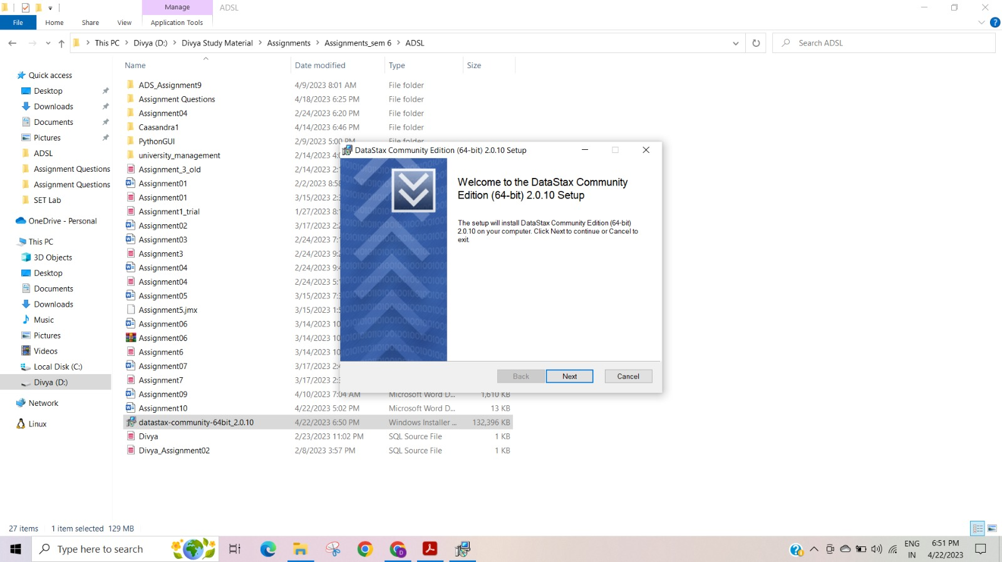

Accept the end-user license agreement.

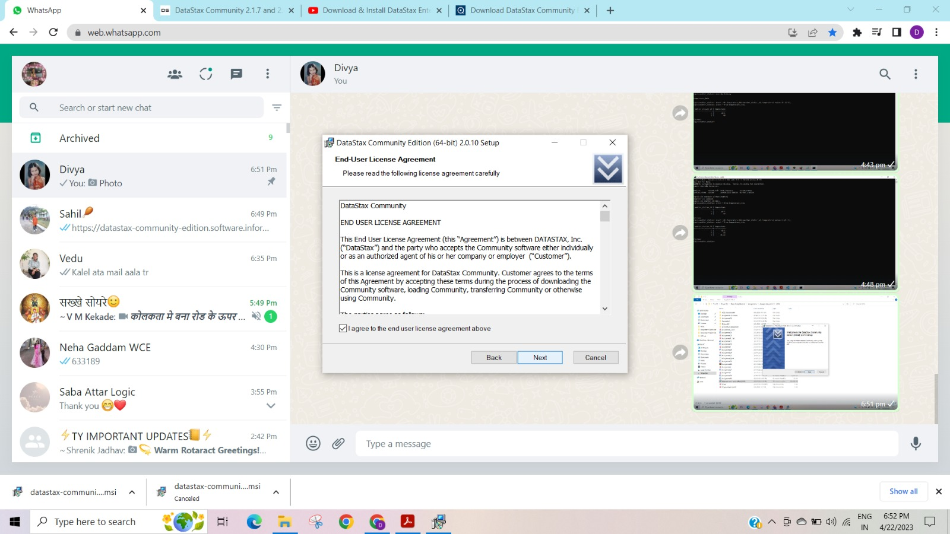

It will ask for permission to start the DataStax community service automatically.

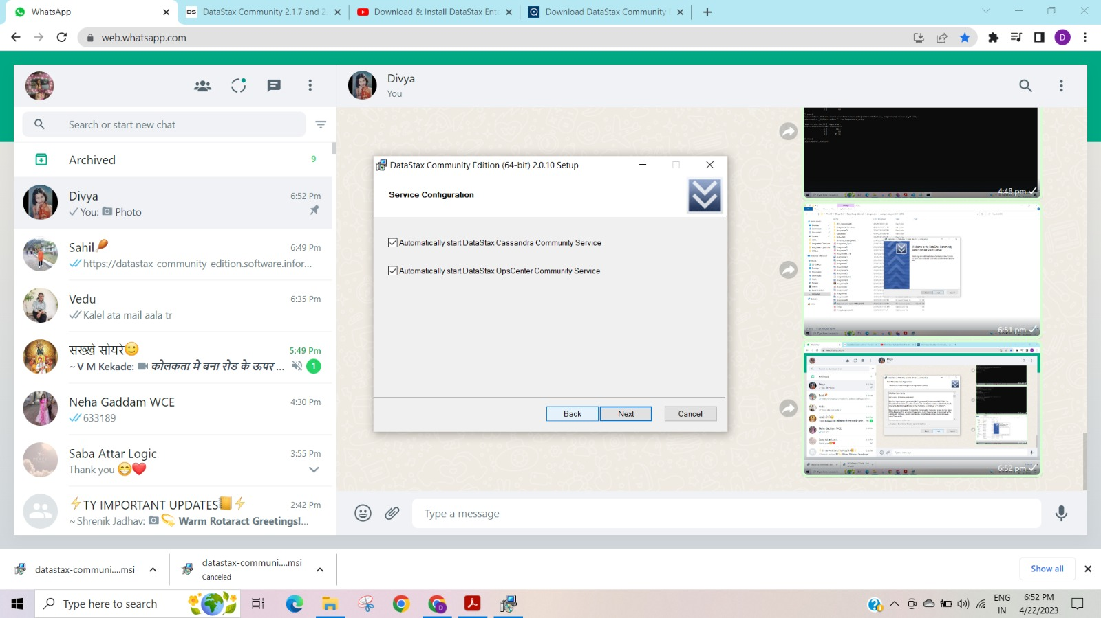

Choose the location for installation.

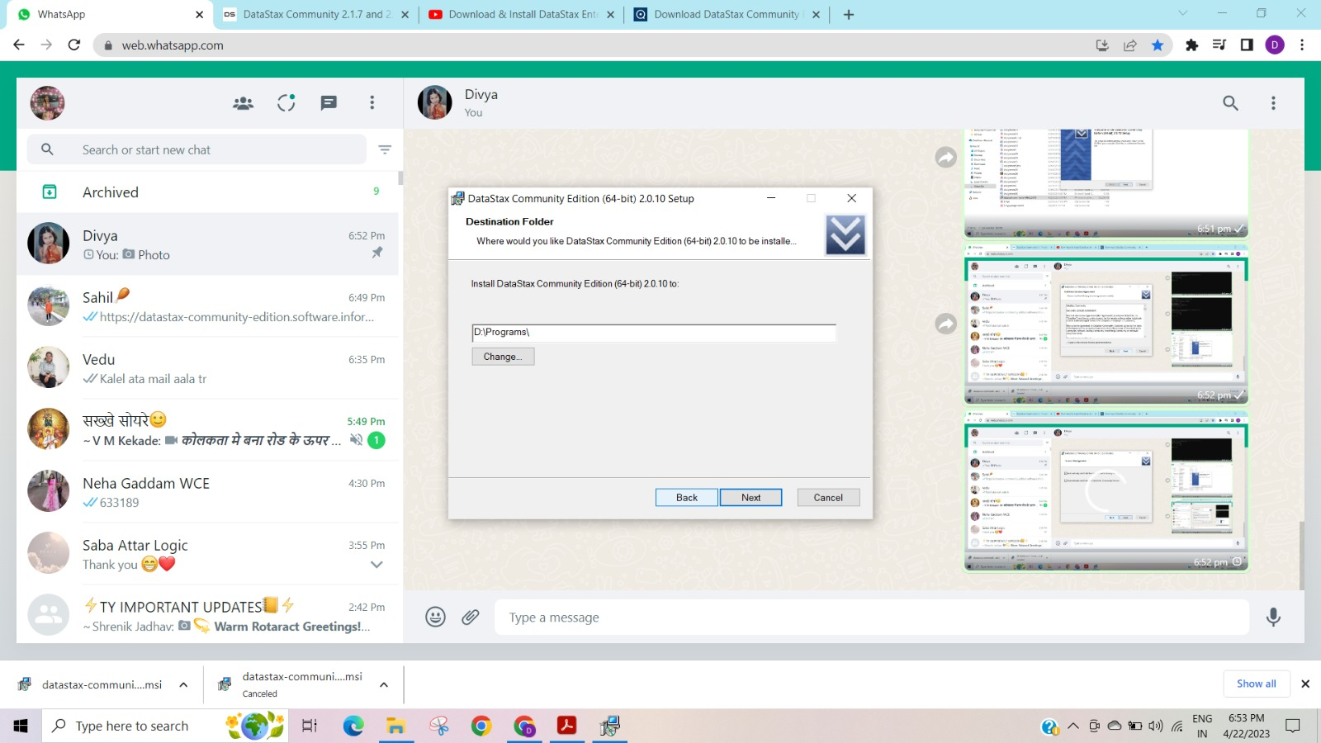

Installation will be started.

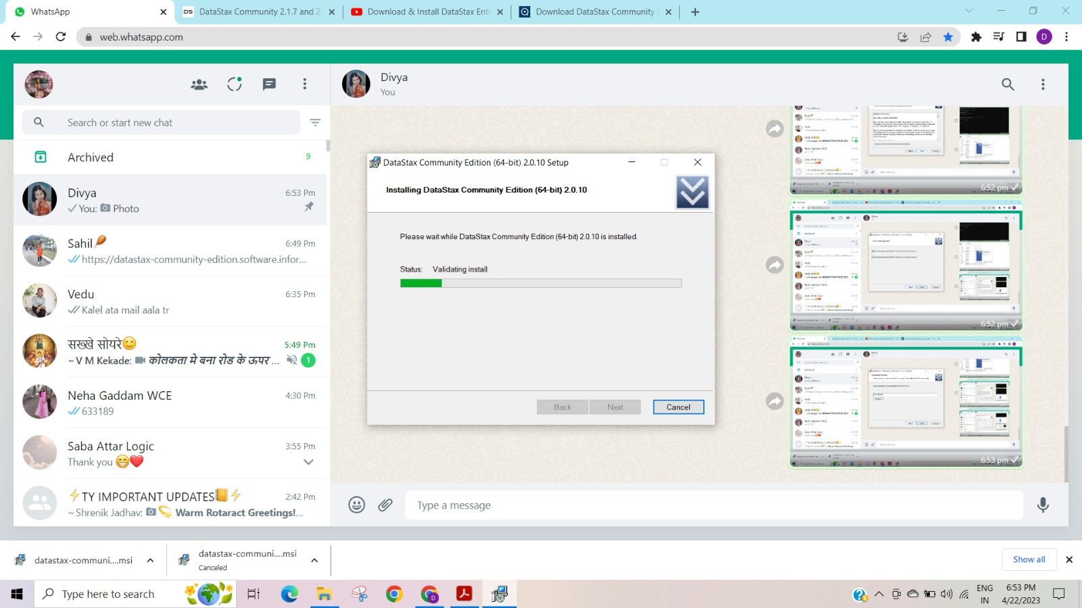

After installation click on finish to complete it.

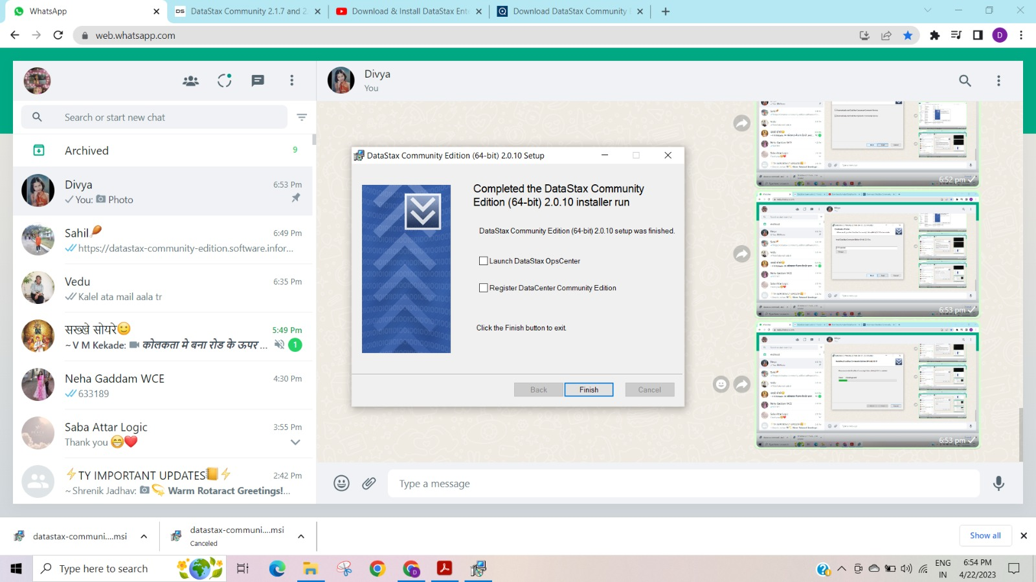

**Creation of the cluster:**

To create the cluster, we need to configure the configuration file “/conf/Cassandra.yaml” with below parameters.

Seeds: Give the list of IP addresses that are going to be the part of cluster.

Listen_address: Give listen address to the IP address of your own node from above list.

Snitch: Change snitch type.

To start the Cassandra server, use “cassandra -f” command in command prompt and after starting the sever successfully. Open the cqlsh command line using command “cqlsh” in command prompt.

To check the list of nodes in the cluster, “nodetool status” command can be used.

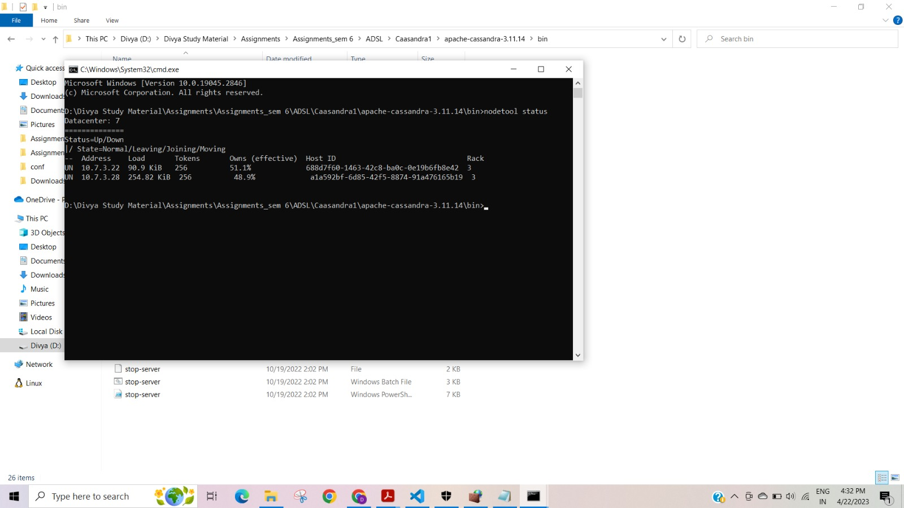

To access the data from database table. Data added from other node gets replicated to all other nodes.

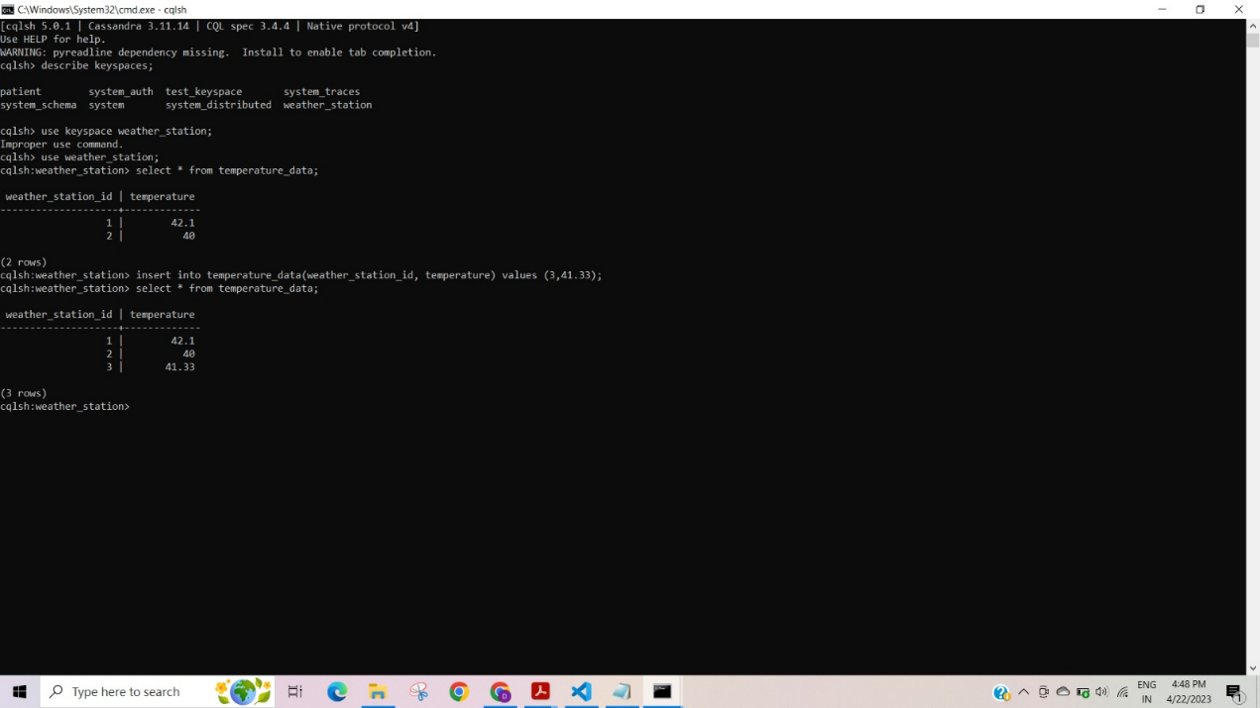

To view all the details of the cluster like all nodes in cluster, nodes that are in up state can be viewed by opening the OpsCenter at localhost:8888.